PIZZA SALES SQL QUERIES

A.KPI’S
1.TOTAL REVENUE
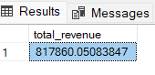
2.AVERAGE ORDER VALUE
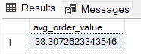
3.TOTAL PIZZA SOLD
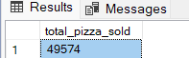

4.TOTAL ORDERS
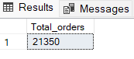
5.AVERAGE PIZZA PER ORDER
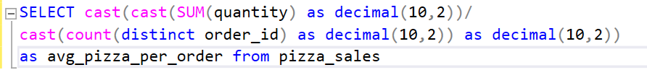
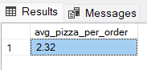

6.DAILY ORDER TRENDS
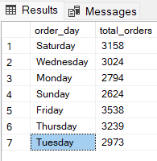

7.HOURLY TRENDS
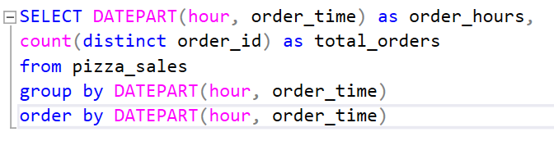
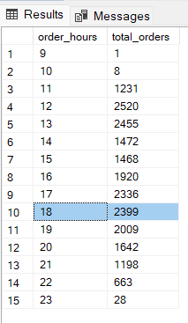

8.SALES PERCENTAGE BY PIZZA CATEGORY
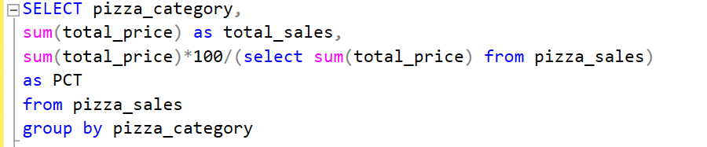
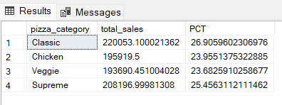
9.SALES PERCENTAGE BY PIZZA CATEGORY IN JANUARY MONTH
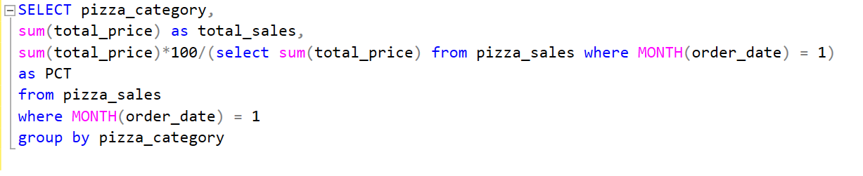
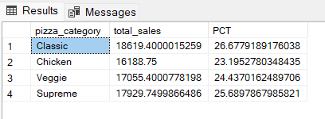
10.SALES PERCENTAGE BY PIZZA SIZE
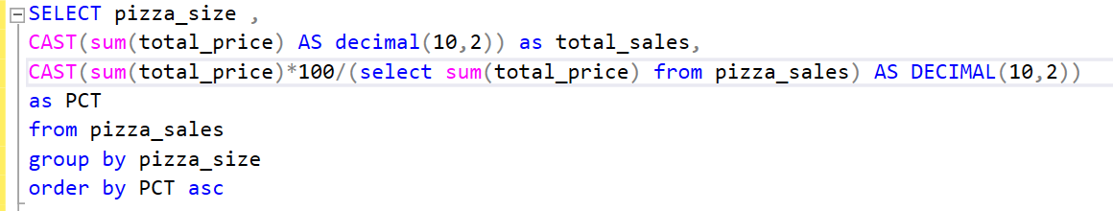
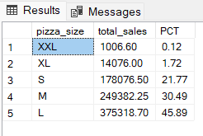
11.SALES PERCENTAGE BY PIZZA SIZE IN 1ST QUARTER
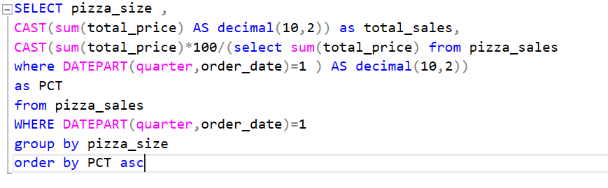
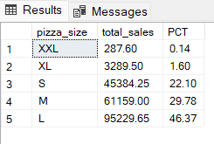

12.TOTAL PIZZAS SOLD BY PIZZA_CATEGORY
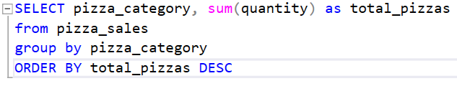
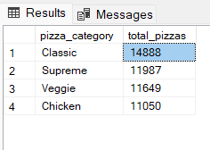
13.TOP 5 BEST SELLER PIZZA NAME
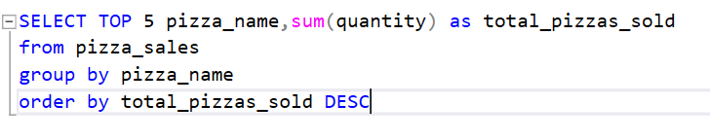
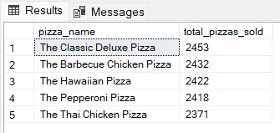

14.BOTTOM 5 WORST SELLER PIZZA NAME
